Device Name: HP – Spectre x360

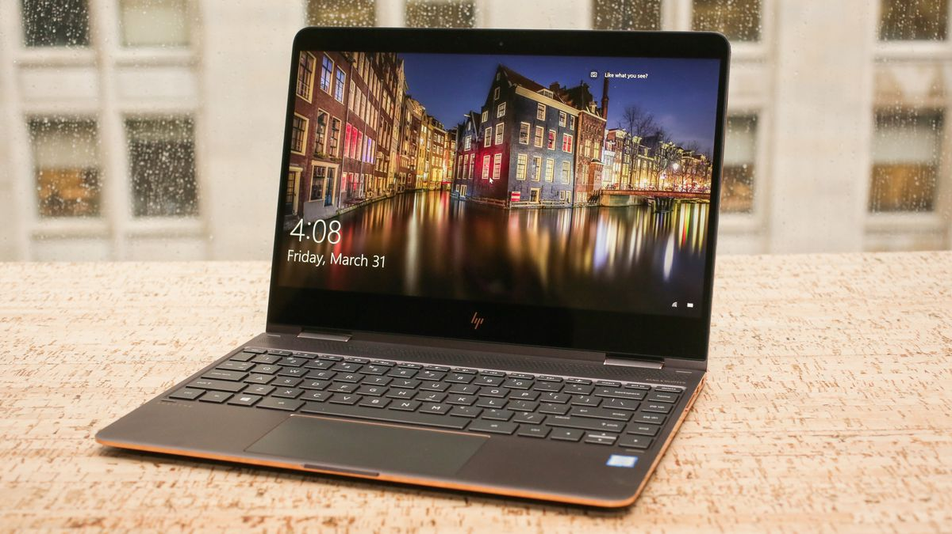

Price: $1700

**SPECIFICATIONS:**

|  |  |
| --- | --- |
| Processor: | Intel Core i7-8565U (1.8 GHz) |
| Memory: | 8 GB DDR4 |
| Storage: | 256 GB |
| Screen Size: | 13 |